**Storage account**

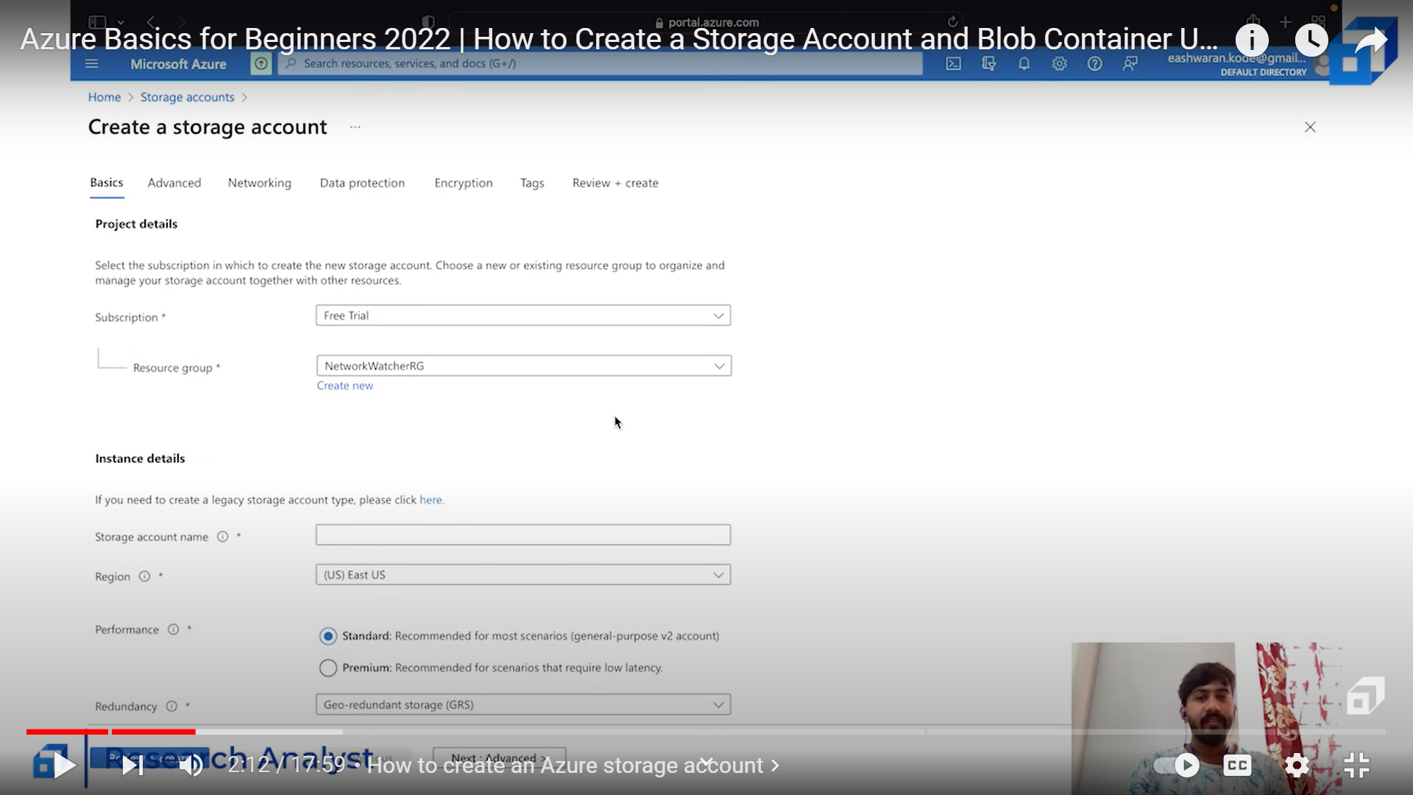

**Storage account name** :: It must be unique

**Performance::**

1.Statndard : used for practice ,

2.Primium: Low latency(fast response),when providing the application to users for use (large number of users)

**Redundancy**::

1. LRS- Locally redundancy storage
2. GRS- globally redundant storage
3. ZRS- Zone redundant storage
4. GZRS- Geo zone redundant storage

Cast income ravasi family pic(4) adaar ration card birth certificate maduve bond